2022-23 KIRPC Head Start Annual Report

Demographics
Site Locations and Funded Enrollment:
Newton County Jasper County Pulaski County

Goodland 19 Rensselaer 20 Winamac 19
Roselawn 20 North Jasper 40 West Central 15

Children attend Monday thru Thursday from 9:30 am to 1:30 pm at the part day sites and 8:30 to 3:00 at the duration sites.
60 Slots are Duration slots and 73 slots are Part Day slots.

Total funded enrollment: 133
Average Monthly Enrollment: 63.5%
Total children served in 2022-23: 123
# 3 year olds: 60
# 4-5 year olds: 63
# English speaking children: 112
# Spanish speaking children: 11
Average Daily Attendance: 80.46%
# In Person Operating Days: 147

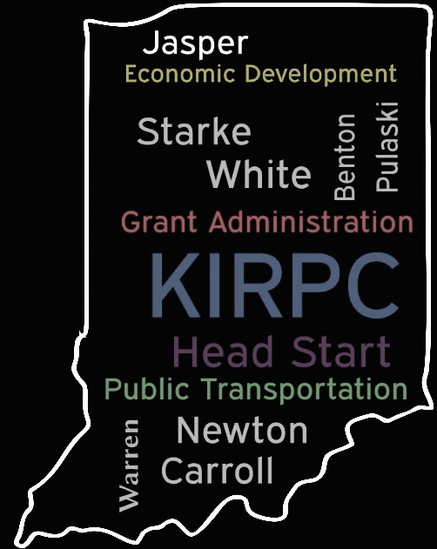
Mission Statement: To build positive relationships with families and provide safe and developmentally appropriate services for children.
Vision Statement: To be a high-quality early education agency and to ensure families have a stronger foundation for success.

Program History
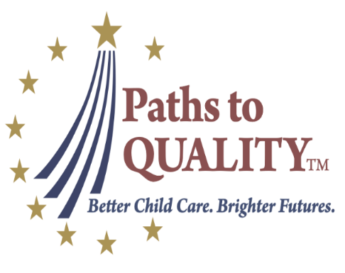
Head Start is a federally funded program for low income, 3-5 year old children and their families. KIRPC Head Start initiated in 1997. Sequestration 2013 resulted in all classrooms becoming 9 month classrooms. One new partnership developed in Fall 2016 when a classroom was moved into the West Central Elementary School. Duration grant funding received in 2017 then resulted in North Jasper and Roselawn extending school hours. The most current Federal Review was conducted in June 2023 where the program received zero findings. The most recent fiscal audit was conducted July 6, 2023 which resulted in zero Head Start findings. North Jasper, Goodland, Rensselaer, and Winamac sites became a Paths to Quality Level 3 in the spring 2019. Roselawn and West Central became a level 3 in the spring 2023. KIRPC celebrated its 50th year as an agency in 2023!
School Readiness
Creative Curriculum is a developmentally appropriate curriculum that utilizes 38 objectives within 9 developmental areas to prepare children for public school. KIRPC uses the first 6 areas that have age related expectation color bands set for each age group. Zoophonics is implemented as a supplemental literacy curriculum focusing on letter sounds prior to letter names.
93% of all children in the program enrolled the entire school year achieved all School Readiness Goals. 91% of children transitioning to Kindergarten achieved all goals. The June 2023 data results below show the percentage of children in the program that met or exceeded the program’s school readiness goals by area:
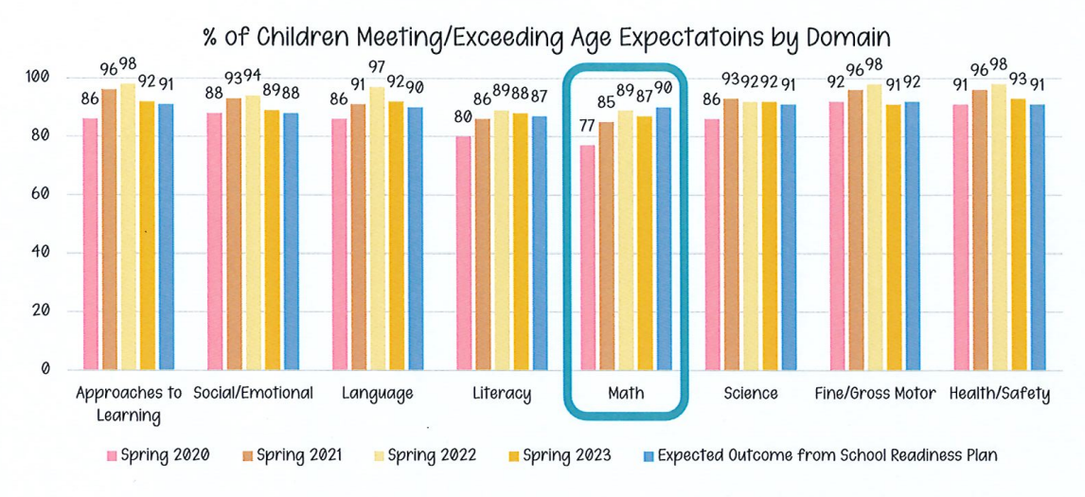

- Number of Staff: 34
- Teachers with Bachelor’s Degree or higher: 14%
- Teachers with Associate’s Degree: 71%
- Number of Staff who are former parents: 5
- Number of Staff who left during the year: 8
- Number of Staff who received coaching: 4

Family Engagement
Family Engagement opportunities emphasize the parent as the children’s first teacher. KIRPC incorporates the Head Start Parent, Family & Community Engagement Framework as the foundation to building relationships with families. The program uses Conscious Discipline as the parenting curriculum.
Engagement Opportunities:
*Family Goal Setting
*Parent Meetings & Trainings
*Parent Education Packets
*Fatherhood Activities
*Family Engagement Activities
*Policy Council Meetings
*Volunteering at the Centers
*Home Visits/Parent Conferences
- 19 men participated in family goal setting;
17 men participated in the family assessment; 56 men participated in home visits/parent conferences; 24 men attended parenting education workshops.
- 206 family goals were set with families this year with 118 achieved and 49 in progress.
- 78 parent trainings were offered this year with 330 parents attending.
Health Outcomes
Children enrolled receive medical, dental, vision, hearing, and social-emotional screenings. Services are monitored to assure children learn lifetime health skills. The Health Department in all three counties helps maintain the immunization reviews twice annually. Mental Health/Disability: Support is provided and referrals are made to assist with identification of needs.
- Number of children with up-to-date immunizations: 112
- Exempt from immunizations: 6
- Number of children with an IEP: 31 (20 Speech/Language, 9 Developmental Delay, 2 Autism)
- A total of 71 absences out of 2325 were COVID-19 related which decreased from the previous year.

Budget
Grant year February 1, 2022 - January 31, 2023 Total Budget = $1,618,217 (Includes COLA increase)
IN-KIND
(Non-Federal Match)
Required Match: $393,192
Received: $210,405.49
(Waiver received for $157,847)
Thank you to all the 315 volunteers and donators that made this possible!

Community Assessment Summary June 2023
The data below is comparing 2021 county statistics to 21-22 school year KIRPC data.
One of the first findings to note is that the websites used for collection are not updated often enough. Specifically, WIC, Foster families, Racial Profile of children under 18, and CHINs data has not been updated since 2017. The program will research different data sources to obtain more current data. It was also discovered that unhelpful Medicaid data was being reported on the Community Assessment report. Previously all Indiana participants were included in the report when only child participants were requested. This 2023 report now shows the accurate child participant data.
KIRPC served 131 children in 2021-22 which was an increase from the previous year. In all three counties, there was an approximate total of 184 3-5 year old children in poverty in the community. Newton County has approximately 52 3 to 5-year-old children in poverty with KIRPC serving 42; Pulaski County has 45 with KIRPC serving 32; and Jasper County has the highest with 86 with KIRPC serving 57. KIRPC will continue to provide the most enrollment slots (60) in Jasper County due to the need of 3-5 year old children in poverty.
KIRPC continues to have sites located in the three largest towns (Rensselaer, Demotte, and Winamac) within the service area. Jasper County is the most populated county with 33,091 (Newton and Pulaski population together only totals 26,147). The program holds the most funded slots in Jasper County with 60. There are 39 slots in Newton and 34 slots in Pulaski County. Jasper County also had the highest percentage of serving children under 5 in poverty at 45% enrolled in Head Start.
The program saw a decrease in applications and waiting lists. Cumulative data shows that KIRPC served 103 children under 100% of poverty, 7 children between 100-130% of poverty, and 8 children over income during the 21-22 school year. This continues to be attributed to the higher household incomes. Median household income went up in Newton County from 2020 to 2021. Pulaski County median household income was the lowest of all three counties and was only under 100% of poverty for a family of 10. To qualify at 130% then it would need to be a family size of 8. Many families who apply for Head Start do not have this large of a family size so if their household income is equal to or greater than the median income data then the families would not be income eligible for the program.
KIRPC served 64 3-year-olds and 67 4-year-olds during the 2021-22 school year. Data shows lack of quality full day pre-kindergartens in the service area therefore equal priority is given to all children 3-5 years old. Community assessment will continue to be reviewed and as community resources change, priority by age will adjust as needed.
30 cumulative children were served who held an IEP of 15 were in Jasper County where public school data also shows the highest number of children with an IEP with 755 total. TANF numbers increased in the counties from 31 to 44 while KIRPC served less with only 3 families on TANF (4 families the in previous year). KIRPC served more children receiving SNAP in the 2021-22 school year with 60 served versus 42 in the previous year even though the county data shows a decrease from 6,285 to 5,028 total SNAP participants among all three counties.
Newton County continues to be the county with the most need due to having the highest poverty rate; highest child food insecurity rate; highest unemployment rate; lowest Bachelor degree rate; the lowest numbers of 4th Graders passing the ISTEP; and the least amount of preschools. KIRPC reviewed data further and found the same patterns exist in the 2021-22 school readiness achievement with only 91.5% versus 95% in Jasper County and 99% in Pulaski.
Program Goals & Objectives
The program is required to set goals in the areas of School Readiness; Family Engagement; Program Governance; and Health & Safety. Each goal is then broken down into specific and measurable, short-term objectives. At the end of the 5-year grant cycle (January 2025), the program hopes to achieve these goals.
Goals | Expected Outcomes Met
GOAL 1 KIRPC Head Start will ensure children make consistent gains in School Readiness. | 2 of 2
GOAL 2 KIRPC Head Start will ensure families make consistent gains in the PFCE Outcomes. | 1 of 1
GOAL 3 KIRPC Head Start will increase efforts to improve staff wellness. | 2 of 3
GOAL 4 KIRPC Head Start will strengthen the program’s governing bodies. | 1 of 3
GOAL 5 KIRPC Head Start will promote child wellness and a culture of safety. | 0 of 2

