KIRPC Head Start
School Readiness Plan
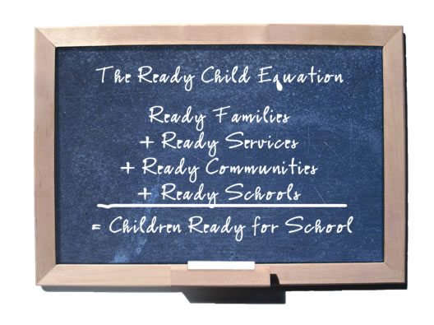
Created 2/2/2012
Policy Council Approved – March 2024 : Revised July 2024


About KIRPC Head Start
KIRPC Head Start provides comprehensive services for 133 children & families in Newton, Jasper & Pulaski Counties in Indiana. There are 7 classrooms located at 6 sites.
KIRPC Head Start Mission Statement
To build positive relationships with families and provide safe and developmentally appropriate services for children.

KIRPC Head Start Vision Statement
To be a high-quality early education agency and to ensure families have a stronger foundation for success.

Head Start’s Approach to School Readiness
The Head Start Approach to School Readiness means that children are ready for school, families are ready to support their children’s learning, and schools are ready for children. Head Start views school readiness as children possessing the skills, knowledge, and attitudes necessary for success in school and for later learning and life. For parents and families, school readiness means they are engaged in the long-term, lifelong success of their child. Head Start recognizes that parents are their children’s primary teachers and advocates.

History of KIRPC Head Start’s School Readiness Plan
The Child Development Sub-Committee (KIRPC staff, parents, & community partners) reviewed the following documents: Head Start Development & Early Learning Framework Promoting Positive Outcomes in Early Childhood Programs Serving Children 3-5 years Old, Teaching Strategies GOLD Objectives for Development & Learning: Birth through Kindergarten, Common Core State Standards for English Language Arts & Literacy in History/Social Studies & Mathematics, local Kindergarten expectations (input given by local Kindergarten teachers), & Teaching Strategies GOLD Performance & Growth Data from the 2010-2011 school year. Teachers developed classroom school readiness goals in the following domains: Language/Literacy, Cognition/General Knowledge, Approaches to Learning, Physical Development/Health, & Social/Emotional Development. The Child Development Sub-Committee then reviewed each school readiness goal and suggestions from local kindergarten teachers. The goals were approved and the KIRPC Head Start School Readiness Plan was released on February 2, 2012.
The Child Development Sub-Committee name was changed to School Readiness Leadership Team (SRLT) on April 12, 2013.
During the October 2015 SRLT meeting, KIRPC Head Start’s School Readiness Plan was realigned to the 2015 Revision of the Indiana Early Learning Foundations.

2016 Alignment
The Administration for Children & Families & The Office of Head Start released Head Start Early Learning Outcomes Framework (ELOF) Ages Birth to Five in 2015 with the expectation that programs implement prior to the 2016-2016 school year. Management, in collaboration, with Training & Technical Assistance (T/TA) reviewed ELOF, Local Expectations of Kindergarten Readiness, Creative Curriculum, Indiana Early Learning Foundations, TS GOLD Assessment Objectives & current School Readiness Goals. Common language was found among the resources and new school readiness goals with specific objectives were created that specifically aligned with ELOF. The new School Readiness Goals were presented to Policy Council & Governing Board in Summer 2016 for review and input. The new goals were approved 7/21/2016 (PC) and 7/28/2016 (GB).
The Child Development Manager created a new School Readiness Plan for review at the October 2016 School Readiness Leadership Team Meeting.

Alignment Resources

Creative Curriculum & TS GOLD Objectives:
KIRPC Head Start follows Creative Curriculum that balances both teacher-directed & child-initiated learning. It places an emphasis on responding to children’s learning styles & building on their strengths & interests. TS GOLD is an ongoing observational system for assessing children from birth through kindergarten. It helps teachers to observe children in every day experiences. TS GOLD is based on 38 objectives for development and learning that include predictors of school success and are based on school readiness standards.
Local Kindergarten Expectations:
Local Kindergarten teachers were given the opportunity to review the KIRPC Head Start Progress Report to provide feedback in regards to what is expected of incoming kindergartners each year. KIRPC Head Start teachers provided information about what is shared with families regarding what children should know prior to entering kindergarten. This information was obtained through routine contact with local kindergarten teachers (Parent Meetings, kindergarten visits, staff collaboration meetings, email, etc.).
Indiana Early Learning Foundations:
The Foundations include the following content areas: English/Language Arts (ELA), Mathematics (M), Student Wellbeing (SW), Approaches to Play & Learning (APL), Science (SC), Social Studies (SS), Creative Arts (CA), and Physical Education (PHG). Also included is a section on supporting Dual Language Learners (DLL) through the use of the WIDA Early English Language Development Standards (E-ELD). 7/5/23 Update: The state of Indiana released updated Indiana Early Learning Foundations with the name changed to Indiana Early Learning Standards. The school readiness goals/objectives were re-aligned with the updated standards.
Parent & Family Engagement Outcomes:
Parent & Family Engagement (PFE) Outcomes are embedded within the Parent, Family, & Community Engagement (PFCE) Framework. The PFCE Framework is the guide used to promote family engagement in school readiness. The PFE Outcomes include: Family Well-Being, Positive Parent-Child Relationships, Families as Lifelong Educators, Families as Learners, Family Engagement in Transitions, Family Connections to Peers & Community, and Families as Advocates & Leaders.
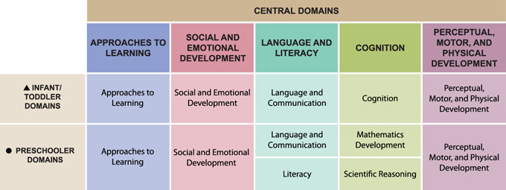
Head Start’s Early Learning Outcomes Framework is divided into domains, or broad areas of early learning & development that are essential for school & long-term success. The central domains for preschoolers are outlined in the table to the left.
The goals & objectives of KIRPC Head Start’s School Readiness Plan are laid out in greater detail in the tables that follow. Each goal is expanded into objectives which shows how they are aligned to Head Start’s Early Learning Outcomes Framework and how success in achieving the goals will be measured.

KIRPC Head Start School Readiness Goal Summary
Domain: Approaches to Learning
Goal: Children will increase the skills & behaviors needed to engage in learning.
Domain: Social & Emotional Development
Goal: Children will build positive relationships & express emotions in a positive way.
Domain: Language & Communication
Goal: Children will increase communication skills by attending to & using the English Language.
Domain: Literacy
Goal: Children will increase literacy skills.
Domain: Cognition – Mathematics Development
Goal: Children will increase mathematical skills.
Domain: Cognition – Scientific Reasoning
Goal: Children will engage in scientific thinking.
Domain: Perceptual Motor & Physical Development
Goal: Children will increase fine & gross motor coordination & skills.
Goal: Children will increase personal health & safety practices.
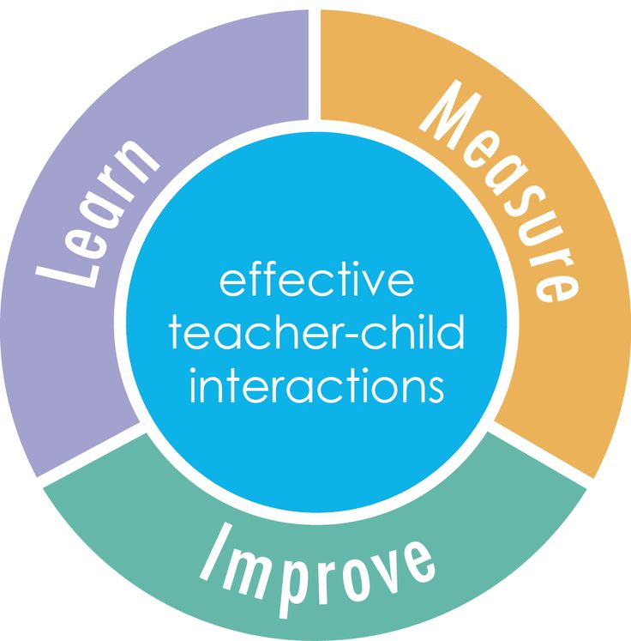
CLASSROOM ASSESSMENT SCORING SYSTEM (CLASS)

CLASS is an observation instrument that assesses the quality of teacher-child interactions. CLASS includes 3 domains or categories of teacher-child interactions that support children’s learning & development:

Emotional Support – Assesses the degree to which teachers establish & promote a positive climate in their classroom through everyday interactions.
Classroom Organization – Assesses classroom routines & procedures related to the organization of the classroom & management of children’s behavior.
Instructional Support – Assesses the ways in which teachers implement the curriculum to effectively promote cognitive & language development.

Within each domain are dimensions which capture more specific details about teachers’ interactions with children.
Positive Climate (PC) – Reflects the emotional connection between the teachers & children and between children.
Teacher Sensitivity (TS) – Reflects the teachers’ awareness of & responsivity to children’s academic & emotional needs.
Regard for Student Perspective (RSP) – Captures the degree to which the teachers’ interactions with children & classroom activities place an
emphasis on children’s interests & points of view and encourages children’s responsibility & autonomy.
Behavior Management (BM) – Reflects the teachers’ ability to provide clear behavioral expectations & use effective methods to prevent
misbehavior.
Productivity (PD) – Reflects how well the teacher manages instructional times & routines & ensures children have the opportunity to be involved.
Instructional Learning Formats (ILF) – Focuses on the ways in which a teacher maximizes students’ interest, engagement & ability to learn.
Concept Development (CD) – Measures the teachers’ use of instructional discussions/activities to promote higher-order thinking skills.
Quality of Feedback (QF) – Assesses the degree to which the teachers provide feedback that expands learning & understanding.
Language Modeling (LM) – Captures the quality & amount of teachers’ use of language.

The CLASS observation may be conducted by one of two certified CLASS observers within the program in October and January. Director, Education Manager, and all site level Peer Coaches are trained.

The observer rates each teacher on a scale of 1 (Low) to 7 (High). KIRPC Head Start has created benchmarks for each domain which are higher than the National Average. Emotional Support: 6.25; Classroom Organization: 6.00; Instructional Support: 4.00. If a teacher’s scores fall below the program’s benchmarks, a professional development referral for coaching is created to support development of CLASS skills.
Approaches to Learning | Goal: Children will increase the skills & behaviors needed to engage in learning.
Approaches to Learning | Objectives | TS GOLD Objectives  (Measurement) | IN Early Learning Standards | Family Engagement Outcomes | Key Teaching Practices  Staff will:
Approaches to Learning | Children will regulate emotions & behaviors with increasing independence. | 1a  1b | SW 1.2  SW 2.1 | Families as Lifelong Educators  Family Engagement in Transitions | - Set clear behavior expectations. (BM)  - Give clear instructions to complete routine tasks (PD)  - Maximize learning time by providing a provision of activities (PD)  - Provide a variety of materials to effectively interest students & gain their participation during activities (ILF)  - Acknowledge emotions & provide individualized support, as needed (TS)  - Provide encouragement & reinforcement (QF)  - Be flexible to go along with students’ ideas & organize instruction around students’ interests (RSP)  - Promote problem solving (CD)
Approaches to Learning | Children will follow multi-step directions. | 8b | ELA 1.1
Approaches to Learning | Children will maintain attention & persist through challenging activities. | 11a  11b | APL 3.1
Approaches to Learning | Children will show initiative to learn about a variety of topics & ideas. | 11d | APL 1.1  APL 1.2
Approaches to Learning | Expected Outcome: 91% of kindergarten bound children will achieve Approaches to Learning goals by performing at or above age expectations.
Social & Emotional Development | Goal: Children will build positive relationships & express emotions in a healthy way.
Social & Emotional Development | Objectives | TS GOLD Objectives  (Measurement) | IN Early Learning Standards | Family Engagement Outcomes | Key Teaching Practices  Staff will:
Social & Emotional Development | Children will establish secure relationships with adults. | 2a | SW 4.1 | Positive  Parent-Child Relationships | - Use positive & respectful communication with students (PC)  - Set clear behavior expectations. (BM)  - Be aware of problems & lack of understanding and respond appropriately (TS)  - Promote problem solving (CD)  - Provide comfort & assistance, when needed (TS)  - Encourage conversations among peers (LM)  - Encourage children to assist each other (PC)  - Participate in social conversations (PC)
Social & Emotional Development | Children will participate in cooperative play with peers. | 2c  2d | SW 4.1  APL 4.1 | Positive  Parent-Child Relationships
Social & Emotional Development | Children will resolve conflicts with peers including sharing & turn taking. | 3a  3b | SW 3.1  APL 4.1 | Positive  Parent-Child Relationships
Social & Emotional Development | Expected Outcome: 88% of kindergarten bound children will achieve Social & Emotional goals by performing at or above age expectations.

Language | Goal: Children will increase communication skills by attending to and using the English Language.
Language | Objectives | TS GOLD Objectives  (Measurement) | IN Early Learning Standards | Family Engagement Outcomes | Key Teaching Practices  Staff will:
Language | Children will gain receptive understanding of language demonstrated by expressive verbal or non-verbal responses. | 8a  37 | ELA 1.1  ELA 1.2 | Family  Well-Being  Family Connections to Peers & Community | - Provides many opportunities for student talk & expression (RSP)  - Participate in frequent conversations with the students (LM)  - Sustains frequent feedback loops – back & forth exchanges – between teacher & students (QF)  - Ask open-ended questions (LM)  - Use & explain a variety of novel words (LM)  - Use self & parallel talk among students (LM)  - Actively facilitate students’ engagement to encourage participation & expanded involvement (ILF)  - Repeat & extend the students’ responses (LM)
Language | Children will use language in conversations to express ideas using varied vocabulary. | 9a 10a  38 | ELA 1.3 | Family  Well-Being  Family Connections to Peers & Community
Language | Expected Outcome: 90% of kindergarten bound children will achieve Language goals by performing at or above age expectations.
Literacy | Goal: Children will increase literacy skills.
Literacy | Objectives | TS GOLD Objectives  (Measurement) | IN Early Learning Standards | Family Engagement Outcomes | Key Teaching Practices  Staff will:
Literacy | Children will identify 15 uppercase & 15 lowercase letters. | 16a | ELA 2.1 | Families as Learners | - Provide a variety of auditory, visual & movement opportunities using interesting & creative materials (ILF)  - Integrate concepts with previous knowledge (CD)  - Relate concepts to students’ actual lives (CD)  - Actively facilitate students’ engagement to encourage participation (ILF)  - Scaffold for students who are having a hard time understanding a question or completing an activity (QF)
Literacy | Children will identify 18 letter sounds. | 16b | ELA 2.2 | Families as Learners
Literacy | Children will decide whether 2 words rhyme. | 15a | ELA 2.2 | Families as Learners
Literacy | Children will independently write their first name. | 19a | ELA 3.1 | Family  Well-Being
Literacy | Expected Outcome: 87% of kindergarten bound children will achieve Literacy goals by performing at or above age expectations.

Cognition  Scientific Reasoning Mathematics |  | Goal: Children will increase mathematical skills.
 |  | Objectives |  | TS GOLD Objectives  (Measurement) |  | IN Early Learning Standards |  | Family Engagement Outcomes |  | Key Teaching Practices  Staff will:
 |  | Children will use number operations to count, pattern, & measure. |  | 20a  22a  23 |  | M 1.1  M 2.2  M 5.1  M 5.2 |  | Families as Lifelong Educators |  | - Provide a variety of auditory, visual & movement opportunities using interesting & creative materials (ILF)  - Integrate concepts with previous knowledge (CD)  - Actively facilitate students’ engagement to encourage participation (ILF)  - Scaffold for students who are having a hard time understanding a question or completing an activity (QF)  - Provide opportunities to classify or compare objects (CD)  - Ask children to explain their thinking & rationale for responses & actions (QF)
 |  | Children will identify numbers & quantities and connect written numerals. |  | 20b  20c |  | M 1.2  M 1.3  M 1.3
 |  | Children will classify, compare & describe shapes & understand spatial concepts. |  | 13  21a 21b |  | M 1.3  M 3.1  M 4.1  M 4.2
 |  | Expected Outcome: 84% of kindergarten bound children will achieve Mathematics goals by performing at or above age expectations.
 |  | Goal: Children will engage in scientific thinking.
 |  | Objectives |  | TS GOLD Objectives  (Measurement) |  | IN Early Learning Standards |  | Family Engagement Outcomes |  | Key Teaching Practices  Staff will:
 |  | Children will engage in exploring their environment by observing, manipulating, classifying & comparing. |  | 22a 22c |  | SC 1.1  SC 1.2  SC 5.1  M 3.1 |  | Families as Lifelong Educators |  | - Be prepared by knowing the lesson & having materials ready (PD)  - Actively facilitate students; engagement to encourage participation (ILF)  - Ask how & why questions to encourage analysis & reasoning (CD)  - Make predictions & conduct experiments (CD)  - Provide opportunities for students to brainstorm & generate their own ideas (CD)  - Make connections to previous knowledge & student’s lives (CD)  - Be flexible to incorporate students’ ideas (RSP)
 |  | Children will participate in experiments & draw conclusions. |  | 11e  12b |  | SC 1.1  SC 1.2  SC 4.1  SC 5.1  ELA 1.2  APL 1.1  APL 1.2
 |  | Expected Outcome: 91% of kindergarten bound children will achieve Scientific Reasoning goals by performing at or above age expectations.
Perceptual, Motor & Physical Development | Goal: Children will increase fine & gross motor coordination & skills.
Perceptual, Motor & Physical Development | Objectives |  | TS GOLD Objectives  (Measurement) |  | IN Early Learning Standards |  | Family Engagement Outcomes |  | Key Teaching Practices  Staff will:
Perceptual, Motor & Physical Development | Children will use traveling movement such as walking, running & jumping. |  | 4 |  | PHG 3.1 |  | Family  Well-Being  Parent-Child Relationships |  | - Set clear behavior expectations. (BM)  - Provide a range of movement activities (ILF)  - Actively facilitate students; engagement to encourage participation (ILF)  - Provide connections to the real world (CD)  - Provide encouragement & reinforcement (QF)
Perceptual, Motor & Physical Development | Children will use balancing skills such as hopping & standing on 1 leg. |  | 5 |  | PHG 3.1
Perceptual, Motor & Physical Development | Children will manipulate objects by throwing, catching & kicking. |  | 6 |  | PHG 3.1
Perceptual, Motor & Physical Development | Children will demonstrate hand strength & coordination by writing, cutting & drawing a self-portrait. |  | 7a  7b |  | PHG 3.1  SS 1.1  CA 3.1  CA 3.2
Perceptual, Motor & Physical Development | Expected Outcome: 96% of kindergarten bound children will achieve Fine & Gross Motor goals by performing at or above age expectations.
Perceptual, Motor & Physical Development | Goal: Children will increase personal health & safety practices.
Perceptual, Motor & Physical Development | Objectives |  | TS GOLD Objectives  (Measurement) |  | IN Early Learning Standards |  | Family Engagement Outcomes |  | Key Teaching Practices  Staff will:
Perceptual, Motor & Physical Development | Children will complete personal care tasks including toileting & handwashing, independently from adults. |  | 1c |  | PHG 1.1  PHG 4.1 |  | Family  Well-Being |  | - Set clear behavior expectations. (BM)  - Anticipate problems & plan appropriately (BM)  - Give clear instructions during routine parts of the day (PD)  - Provide comfort & assistance, when needed (TS)  - Give children responsibilities within the classroom (RSP)  - Participate in shared activities to model tasks throughout the day (PC)
Perceptual, Motor & Physical Development | Children will follow basic safety rules with adult guidance. |  | 1b |  | PHG 1.2
Perceptual, Motor & Physical Development | Expected Outcome: 94% of kindergarten bound children will achieve Personal Health & Safety goals by performing at or above age expectations.

5 Year Goal Expected Outcome: 90% of kindergarten bound children will achieve all school readiness goals by performing at or above age expectations.
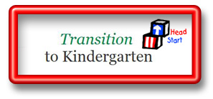
KINDERGARTEN TRANSITION PLAN
MONTH | ACTION STEPS
August | - Parent Orientation –Begin building relationships; Parent Education; Share School Expectations, Encourage Responsibility for follow through with paperwork and other parent responsibilities  - Introduce Family Engagement Activities  - Create individualized child school readiness goals.  - Distribute School Readiness Goals/Objectives to all families at the 1st Home Visit  - Administer DIAL 4 Screening  - Teach school routines to children.
September | - Send home School Readiness Backpack to all children 2 weeks after enrollment.  - Create individualized family transition goals, as needed.  - Health Department Nurse reviews immunization records of enrolled children.  - Begin weekly Family Engagement Activities.
October | - Begin to schedule and/or hold School Readiness/Transition Parent Meetings.  - Contact & invite a local kindergarten teacher to share expectations of elementary school at Parent Meeting (teachers obtain kindergarten expectations to share at 1st PTCs). Discuss the similarities and differences between Head Start & Elementary schools (HS children vs students, Policy Council vs Parent Teacher Association, enrollment vs registration, etc).  - Teaching staff reach out to kindergarten teachers to check on children who have transitioned from previous year (via email).  - Contact & invite a past parent to share their transition experience at Parent Meeting.  - Obtain kindergarten expectations packet from local school
November | - 1st Parent/Teacher Conferences – Share Kindergarten Information Packets, including kindergarten expectations from local school  - Update individualized Family & Child goals.  - Share Progress Reports with families.
December | - Prepare & send home a Kindergarten packet of activities to work on over Winter Break.
January | - Begin discussions with children about kindergarten transition (who is going to kindergarten, teachers & friends will change).
February | - Partner with local elementary schools for Preschool Parent Nights, if scheduled.  - Notify families about kindergarten screening dates. Share on monthly calendars and site Facebook groups.  - Print registration forms from elementary schools’ websites to share with families, as needed.  - Encourage families to sign children up for Round-Up/Screening/Registration  - 2nd Parent/Teacher Conferences – Share Progress Reports & update individualized child & family goals
March | - Encourage parents to keep screening appointments.  - Begin to meet with local kindergarten teachers to discuss screening results.  - Share Kindergarten Registration dates with families & encourage parents to register children for kindergarten.  - Participate in Transition Case Conferences with LEAs and elementary schools.  - Schedule Kindergarten field trips with local kindergarten classrooms – in person or ZOOM or video recording.  - KIRPC Transition Plan is reviewed at Teacher Time Meeting
April | - Encourage parents to register children for kindergarten.  - FES/Teachers will assist parents in communicating with their child’s elementary school as requested.  - Begin Kindergarten Field Trips  - Continue to meet with local kindergarten teachers to discuss screening results.  - Provide local kindergarten teachers with information regarding incoming children.  - Begin Getting Ready for Kindergarten Study  - Participate in Transition Case Conferences with LEAs and elementary schools.
May | - 2nd Home Visit – Share Progress reports and update Individualized child & family goals (Part Day Sites)  - 2nd Home Visit – Share “Selected Children’s Books about Kindergarten” list found on Google Drive. (Part Day Sites)  - Encourage families to create & practice morning & evening routines to use during the child’s kindergarten year.  - Review Immunization Records for children going to kindergarten to ensure they are up-to-date.  - Prepare and send home Kindergarten BINGO sheet to complete over summer break (part day sites).  - Share pictures of kindergarten teachers on site Facebook page, if available (pictures or introduction video).  - Participate in Transition Case Conferences with LEAs and elementary schools.
June | - Reminder letters are sent about upcoming school year in kindergarten.  - Well Wishes cards are sent to children going to kindergarten.  - 2nd Home Visit – Share Progress reports and update Individualized child & family goals (Duration Sites)  - 2nd Home Visit – Share “Selected Children’s Books about Kindergarten” list found on Google Drive. (Duration Sites)  - Prepare and send home Kindergarten BINGO sheet to complete over summer break (duration sites).  - Education Manager obtains & maintains partnership agreement with local elementary schools  - Education Manager contacts & Schedule LEAs to administer Language of DIAL 4.  - FES/FEM share on Facebook school supply resources/flyers (Pack a Backpack, etc), if known.  - Share summer reading programs from local libraries, if known.
On-Going | - Upon In-Take, families are asked which elementary school child will be attending.  - Monthly contact with Family Engagement Specialists – update progress for Family Transition Goals  - Health Department Nurse reviews immunization records of enrolled children.  - Large & Small groups are planned with the focus on School Readiness Goals.  - Practice opening milk cartons.  - Read books about kindergarten.  - Copy child’s paperwork, if requested by family.  - Information about Kindergarten is provided in both English & Spanish (discussions at HVs & PTCs, readiness checklists, parent meetings, etc).  - When kindergarten bound children withdraw early, teaching staff will provide a copy of the child’s most current progress report to the family. The progress report may be mailed if the address is known.

